**NHANES Hypertension EDA Results**

**Ethan Bard**

**Florida Polytechnic University**

**05 June 2021**

| Prevalence of Hypertensive Drug Categories 2013-2018 | |
| --- | --- |
|  | |
| Drug Category | Count |
| ACE | 1659 |
| CCB | 1473 |
| BB | 1375 |
| diuretic | 1191 |
| ARB | 882 |
| other | 624 |
| AB | 46 |

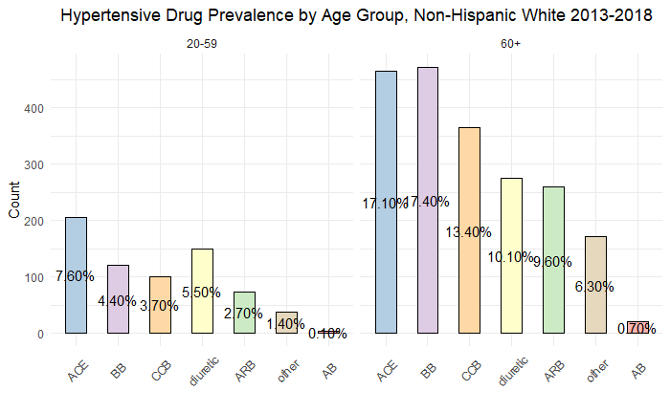

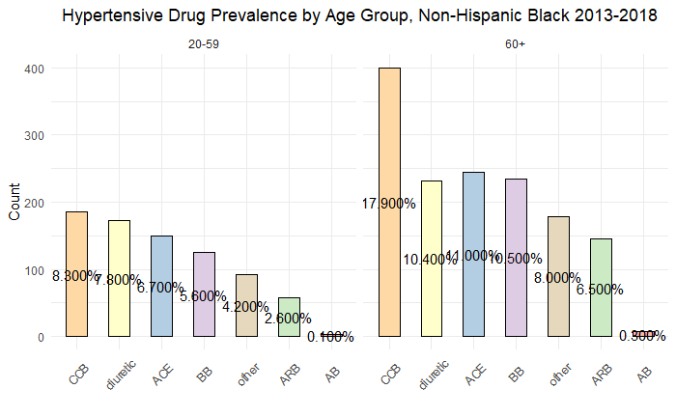

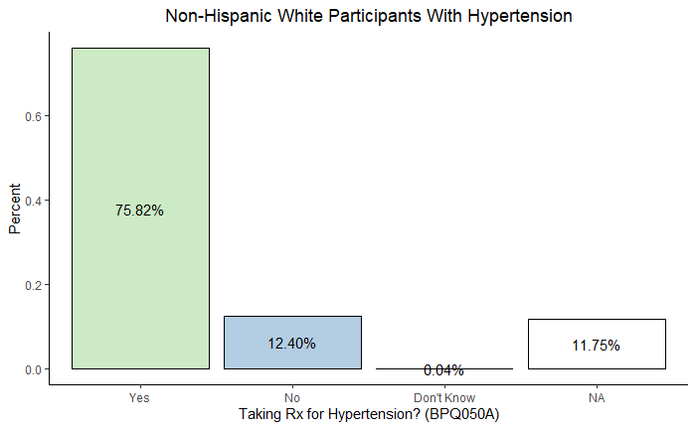

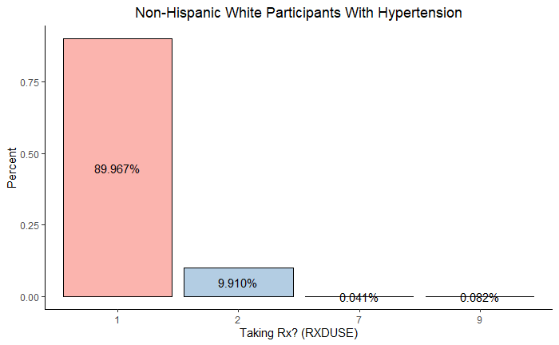

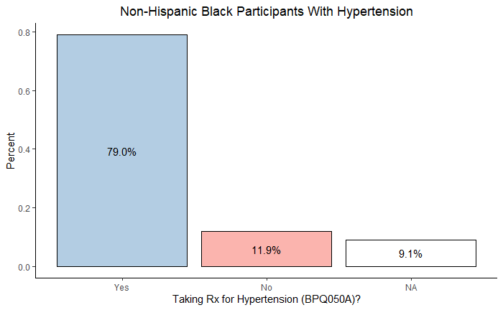

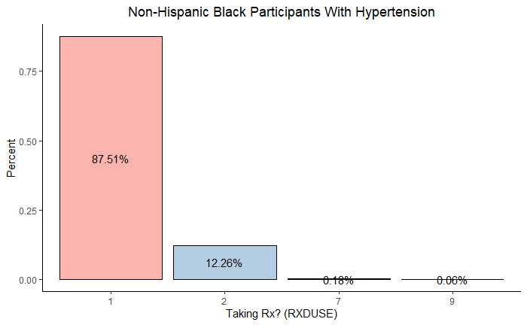

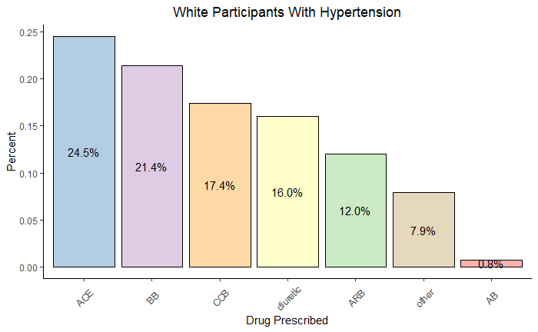

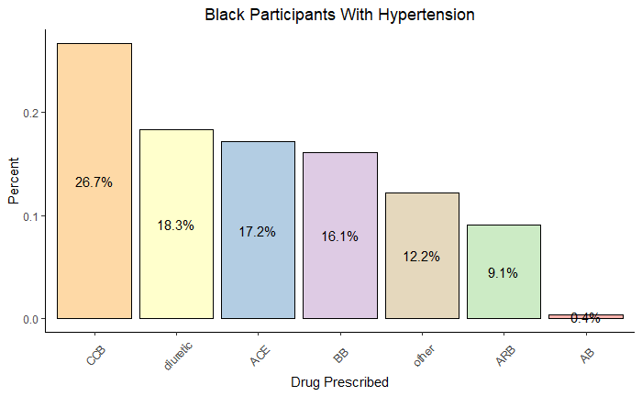

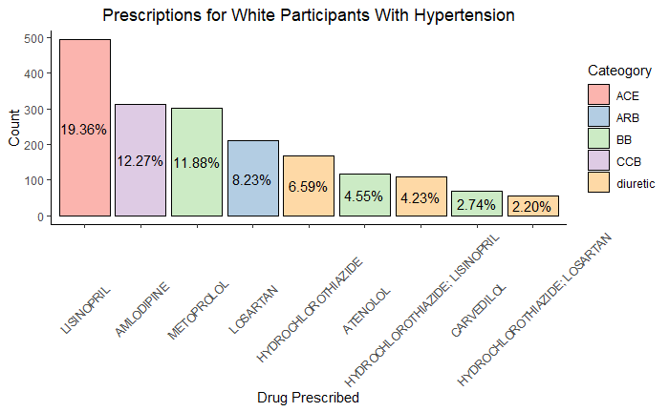

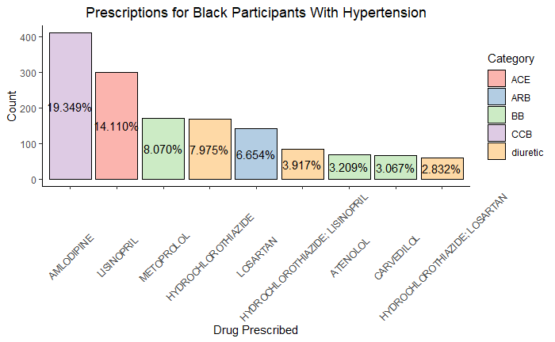

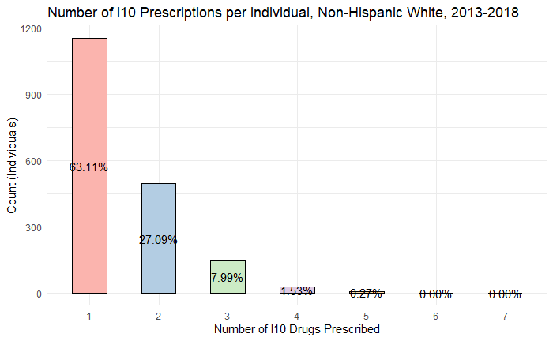

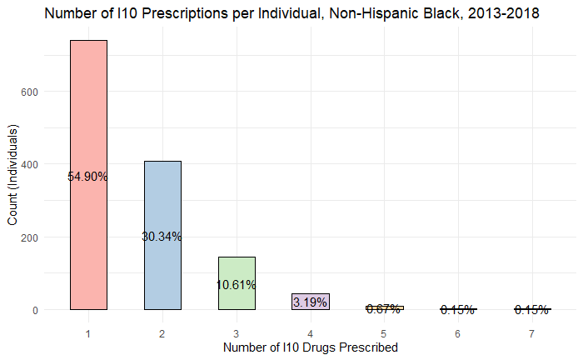

| Most Common Combinations of Drug Categories, Non-Hispanic White | | | | | | | | |
| --- | --- | --- | --- | --- | --- | --- | --- | --- |
|  | | | | | | | | |
| ACE | BB | CCB | ARB | AB | diuretic | other | Freq | perc |
| 0 | 0 | 0 | 0 | 0 | 0 | 0 | 735 | 29.976% |
| **1** | 0 | 0 | 0 | 0 | 0 | 0 | 340 | 13.866% |
| 0 | 0 | 0 | 0 | 0 | **1** | 0 | 203 | 8.279% |
| 0 | **1** | 0 | 0 | 0 | 0 | 0 | 191 | 7.790% |
| 0 | 0 | 0 | **1** | 0 | 0 | 0 | 142 | 5.791% |
| 0 | 0 | **1** | 0 | 0 | 0 | 0 | 132 | 5.383% |

| Most Common Combinations of Drug Categories, Non-Hispanic Black | | | | | | | | |
| --- | --- | --- | --- | --- | --- | --- | --- | --- |
|  | | | | | | | | |
| ACE | BB | CCB | ARB | AB | diuretic | other | Freq | perc |
| 0 | 0 | 0 | 0 | 0 | 0 | 0 | 423 | 24.694% |
| 0 | 0 | **1** | 0 | 0 | 0 | 0 | 178 | 10.391% |
| **1** | 0 | 0 | 0 | 0 | 0 | 0 | 172 | 10.041% |
| 0 | 0 | 0 | 0 | 0 | **1** | 0 | 170 | 9.924% |
| 0 | 0 | **1** | 0 | 0 | **1** | 0 | 80 | 4.670% |
| 0 | **1** | 0 | 0 | 0 | 0 | 0 | 78 | 4.553% |

**Appendix**

| Hypertensive Drug Prevalence Non-Hispanic White 2013-2018 | | | |
| --- | --- | --- | --- |
| N = 2718 | | | |
| Age Group | Drug | Count | percent |
| 60+ | BB | 472 | 17.37% |
| 60+ | ACE | 464 | 17.07% |
| 60+ | CCB | 364 | 13.39% |
| 60+ | diuretic | 275 | 10.12% |
| 60+ | ARB | 260 | 9.57% |
| 20-59 | ACE | 206 | 7.58% |
| 60+ | other | 171 | 6.29% |
| 20-59 | diuretic | 150 | 5.52% |
| 20-59 | BB | 120 | 4.42% |
| 20-59 | CCB | 101 | 3.72% |
| 20-59 | ARB | 74 | 2.72% |
| 20-59 | other | 38 | 1.40% |
| 60+ | AB | 20 | 0.74% |
| 20-59 | AB | 3 | 0.11% |

| Hypertensive Drug Prevalence Non-Hispanic Black 2013-2018 | | | |
| --- | --- | --- | --- |
| N = 2230 | | | |
| Age Group | Drug | Count | percent |
| 60+ | CCB | 400 | 17.94% |
| 60+ | ACE | 245 | 10.99% |
| 60+ | BB | 235 | 10.54% |
| 60+ | diuretic | 232 | 10.40% |
| 20-59 | CCB | 186 | 8.34% |
| 60+ | other | 178 | 7.98% |
| 20-59 | diuretic | 173 | 7.76% |
| 20-59 | ACE | 150 | 6.73% |
| 60+ | ARB | 145 | 6.50% |
| 20-59 | BB | 125 | 5.61% |
| 20-59 | other | 93 | 4.17% |
| 20-59 | ARB | 58 | 2.60% |
| 60+ | AB | 7 | 0.31% |
| 20-59 | AB | 3 | 0.13% |